Assignment no 9

1) Write a query that lists each order number followed by the name of the customer who made the order.

Ans :-

select ORDERS.onum, CUSTOMERS.cname from CUSTOMERS,ORDERS where CUSTOMERS.cnum = ORDERS.cnum;

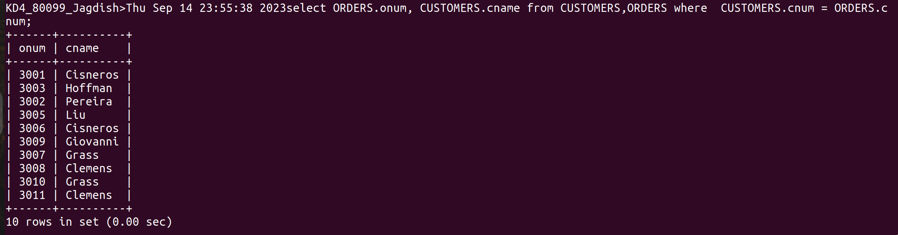
2) Write a query that gives the names of both the salesperson and the customer for each order along with the order number.

Ans :-

select SALESPEOPLE.sname, CUSTOMERS.cname from ORDERS, CUSTOMERS, SALESPEOPLE where ORDERS.snum = SALESPEOPLE.snum and ORDERS.cnum=CUSTOMERS.cnum;

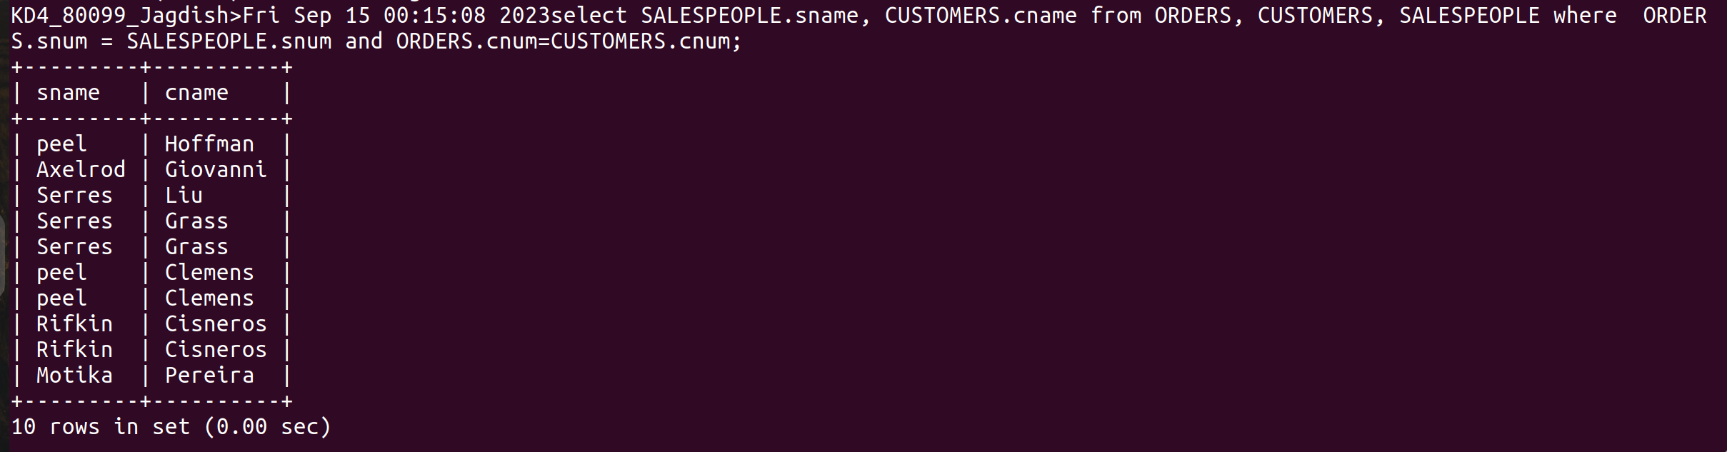

3) Write a query that produces all customers serviced by salespeople with a commission above 12%. Output the customer’s name, the salesperson’s name, and the salesperson’s rate of commission.

Ans :-
select CUSTOMERS.cname,SALESPEOPLE.sname,SALESPEOPLE.comm from CUSTOMERS,SALESPEOPLE where CUSTOMERS.snum=SALESPEOPLE.snum having comm >.12;

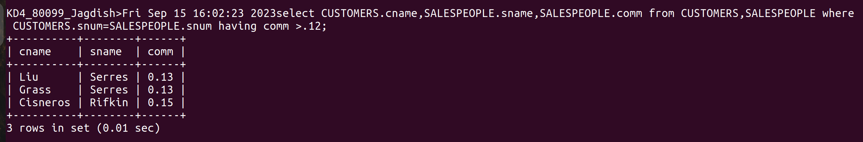

4) Write a query that calculates the amount of the salesperson’s commission on each order by a customer with a rating above 100.

Ans :-
select onum,amt * comm from ORDERS,CUSTOMERS,SALESPEOPLE where SALESPEOPLE.snum=CUSTOMERS.snum and ORDERS.cnum=CUSTOMERS.cnum and rating > 100;

